BACHELOR OF ENGINEERING HONORS DEGREE IN TELECOMMUNICATIONS ENGINEERING

NATIONAL UNIVERSITY OF SCIENCE AND TECHNOLOGY
FACULTY OF INDUSTRIAL TECHNOLOGY
DEPARTMENT OF TELECOMMUNICATIONS ENGINEERING

PROJECT TITLE:
ROLE-BASED DIGITAL PLATFORM CONNECTING CATTLE AND GOAT FARMERS, VETERINARIANS, SUPPLIERS, BUYERS, POLICE AND FINANCIAL INSTITUTIONS AROUND A VERIFIED LIVESTOCK REGISTRY, MARKETPLACE AND SALE-CLEARANCE SYSTEM (PFUMA/INGCEBO)

By

Student Name: Arnold T. Mapindu
Student Number: [STUDENT NUMBER]
Supervised by: [SUPERVISOR NAME AND TITLE]

This Project is submitted in partial fulfillment of the requirement for the award of a Bachelor of Engineering (honors) Degree in Telecommunications Engineering

Submission Date: [SUBMISSION MONTH] 2026

EXAMINING COMMITTEE REPORT
We certify that we have read this graduation project report as examining committee, examined the student in its content and that in our opinion it is adequate as a project document for Bachelor of Engineering Honors Degree in Telecommunications Engineering.

Supervisor: | Examiner 1: | Examiner 2:
Name: .......................... | Name: .......................... | Name: ..........................
Signature: .................... | Signature: .................... | Signature: ....................
Date: / / | Date: / / | Date: / /

DEDICATION
To my parents, who paid for the years of schooling that made this possible. To the rural farmers whose livestock keeps them fed and solvent, and who deserve better than a paper record that can be lost, forged, or never have existed in the first place.

ACKNOWLEDGEMENTS
The guidance of the project supervisor, [Supervisor Name], is gratefully acknowledged. Appreciation is also extended to the academic and technical staff of the Department of Telecommunications Engineering at the National University of Science and Technology, and to the Telone Centre for Learning, for the teaching and facilities that supported this study.
Thanks are due to the farmers, veterinary practitioners and community members who described, in ordinary conversation, how a livestock sale or a disease outbreak is actually handled in practice — that ordinary description is what shaped the platform's role structure more than any single document did. Finally, the author thanks his family for their support and patience throughout the period of study.

COPYRIGHT STATEMENT
All rights reserved. No part of this project may be reproduced, stored in any retrieval system or transmitted in any form or by any means, electronic, mechanical, photocopying, recording or otherwise from scholarly purpose without the prior written permission of the author or of National University of Science and Technology or Telone Centre for Learning on behalf of the author.

DECLARATION
This project is my original work except where the sources are acknowledged. No portion of the work contained during this document has been submitted in support of any application for the other degree or qualification of this or the other university or institute of learning.

ABSTRACT
Livestock is frequently the largest store of wealth held by a rural Zimbabwean household, yet ownership, health and sale records for that wealth are commonly kept on paper, by memory, or not kept at all. This leaves a buyer unable to verify what is being purchased, a bank or insurer unable to lend against livestock as collateral, and a police officer without a fast way to tell a lawful sale from a stolen animal.
This study addressed that gap. A role-based digital platform was designed and developed, giving each participant in a livestock transaction, namely the farmer, the veterinary practitioner, the supplier, the buyer, the police officer, and a financial institution, a shared and checkable record. The platform was implemented as a web application and a companion mobile application, backed by a single relational database. A livestock listing created by a farmer was made to remain hidden from buyers until police clearance had been recorded against it, mirroring the clearance process already used in Zimbabwean livestock trade.
The platform was built, deployed on a local server, and exercised directly, and its registry, marketplace, compliance and communication workflows were confirmed to operate end to end. The study concluded that a verified-record pattern of this kind is achievable entirely in software, and that it directly addresses the traceability gap identified at the outset.
Keywords: Livestock traceability, Digital registry, Role-based access control, Verification-gated marketplace, Multi-role platform, Mobile application, Relational database, Agricultural technology

TABLE OF CONTENTS
Press Ctrl+A then F9 in Word to populate this list.

LIST OF TABLES
Press Ctrl+A then F9 in Word to populate this list.

LIST OF FIGURES
Press Ctrl+A then F9 in Word to populate this list.

LIST OF ACRONYMS AND SYMBOLS
Acronym | Expansion
API | Application Programming Interface
CVSZ | Council of Veterinary Surgeons of Zimbabwe
DVS | Department of Veterinary Services
HTTP | Hypertext Transfer Protocol
HTTPS | Hypertext Transfer Protocol Secure
JSON | JavaScript Object Notation
JWT | JSON Web Token
NUST | National University of Science and Technology
PWA | Progressive Web Application
REST | Representational State Transfer
SQL | Structured Query Language
UI | User Interface
URL | Uniform Resource Locator
UX | User Experience
ZRP | Zimbabwe Republic Police

CHAPTER 1 INTRODUCTION

1.1 INTRODUCTION
This chapter introduces PFUMA/INGCEBO, a role-based digital platform developed to turn livestock ownership, health history and sale history into a record that a third party can trust and check, in place of paper, memory, or a stranger's word. The chapter sets out the background against which the platform was developed, states the problem being addressed, presents the solution, the aim and the objectives of the study, justifies the work, defines its scope, states its limitations and delimitations, and describes how the remainder of the document is organised.

1.2 BACKGROUND
Livestock is frequently the largest store of wealth held by a rural Zimbabwean household, and it is commonly the least protected asset that household owns. Ownership, vaccination history, weaning and gestation dates, and past sales are typically tracked on paper, by memory, or not tracked at all. A record kept this way can be lost, forged, or simply never have existed, and it cannot be produced quickly when it is needed most: at the point of sale, at a police checkpoint, or when a bank is asked to lend against the animal as collateral.
Zimbabwean law already recognises how serious the resulting gap is. The Stock Theft Prevention Act criminalises the theft of stock and produce, and receiving stock known or reasonably suspected to be stolen, and it places a duty on traders to keep transaction registers precisely because an undocumented sale is the easiest route for a stolen animal to be laundered into legitimate trade [1]. In ordinary practice, a livestock sale in Zimbabwe is expected to pass through an ownership check, a veterinary inspection, and a police clearance before it is considered safe, but this process is currently a manual, paper-based one, carried out separately by a village head, a veterinary officer and a police officer with no shared system connecting their records.
A parallel identification framework requires cattle to be branded and, in newer regulation, tagged, with the brand encoding the owner, the village of origin, the dip tank and the district the animal belongs to [2]. Disease control is likewise governed by statute: notifiable diseases must be reported, and the state holds quarantine and movement powers precisely because an outbreak can spread faster than paper record-keeping and word-of-mouth warning can respond to it [3]. Veterinary practice itself is a regulated profession, with practitioners required to be registered before they may certify an animal's health [4]. Each of these legal instruments assumes a functioning paper trail; none of them currently has a shared digital system behind it.
A related, more commercial gap sits alongside the legal one. A farmer with an animal to sell has no reliable way to find a buyer known to be creditworthy and genuine, and no independent figure to point to when negotiating a price, so a sale is commonly conducted by word of mouth, with a wandering buyer offering whatever price the farmer cannot readily check against anything. Certified buyers and a credible valuation are, in practice, as hard to find as a clean ownership record is.

1.3 PROBLEM STATEMENT
Proof of a livestock asset's ownership and health history does not currently exist in a form that a third party, whether a buyer, a police officer, or a bank, can independently trust. The professionals who each create part of that history in the course of their work, namely the farmer, the veterinary practitioner, and the police officer performing a clearance, have no shared system in which to record it, so each keeps a separate, private, and often paper-based account. The result is that a buyer cannot verify what is being purchased before paying, a police officer cannot quickly confirm that a listed animal has actually been cleared, a bank or insurer cannot treat livestock as usable loan collateral because no verifiable record of its value or ownership history exists to lend against, and a farmer with an animal to sell has no efficient way to reach a buyer known to be certified and genuine or to point to a credible, independent valuation when a price is negotiated.

1.4 SOLUTION
PFUMA/INGCEBO was developed as a multi-role web and mobile platform that connects the farmer, the veterinary practitioner, the supplier, the buyer, the police officer, and a financial institution into one shared record. Because every account on the platform has already passed the same signup-verification gate described above, a buyer reached through the marketplace is a certified one by construction, rather than a stranger a farmer must take on faith. Every registered animal carries an identity, a health timeline and an ownership history that each authorised role can contribute to and check. A livestock listing created for sale is held back from buyers until a police officer has recorded clearance against it, reproducing in software the ownership-and-clearance sequence already expected of a lawful sale. An animal's owner can issue a valuation certificate carrying a code that anyone, including a bank or insurer, can look up independently; its value is computed by the platform itself from the animal's weight, a per-species market rate, and a bonus reflecting the animal's logged veterinary health events, turning that health record into something that can support a loan application rather than only a private note in a practitioner's file. The same shared record drives automatic vaccination, weaning and gestation countdowns that raise a compliance case when a deadline is missed, and feeds a market-rate scan that keeps an animal's estimated value current rather than static. The platform further supports a secure messenger reaching any role directly, a farmer cooperative's shared dip-tank schedule and group veterinary request, a feed-formulation function that plans a farmer's own dry-season feed budget, a trading-journal function summarising a supplier's or buyer's own trade history, an outbreak-reporting pipeline that broadcasts a verified disease alert to every affected farmer, and a role-aware natural-language assistant that answers a farmer's health and legal-compliance questions in plain language. Every function is delivered through both a web application and a native mobile application, so no role is limited to a single device.

1.5 AIM
The aim of the project is to develop a role-based digital platform connecting farmers, veterinary practitioners, suppliers, buyers, police officers and financial institutions around a single verified livestock record, giving every role a shared registry, marketplace, messaging and clearance system in place of separate paper trails.

1.6 OBJECTIVES
The objectives of the study, listed in the chronological order in which the corresponding work was undertaken, were:
- To design a relational database schema and a role-based access-control mechanism serving seven distinct platform roles.
- To develop a livestock registry that records an animal's identity, health timeline and ownership history.
- To develop a health-and-compliance lifecycle that tracks a vaccination, weaning or gestation countdown and raises a compliance case when a deadline is missed.
- To develop a marketplace listing mechanism that withholds a livestock listing from a buyer until police clearance has been recorded against it.
- To develop a valuation-certificate workflow that computes and issues a publicly verifiable certificate for a registered animal, informed by its logged veterinary health events.
- To create an institution ledger function that allows a valuation certificate to be looked up and flagged for loan-collateral purposes.
- To develop an outbreak-reporting and verification pipeline that broadcasts a confirmed disease alert to farmers in the affected region.
- To develop a farmer cooperative function that shares a dip-tank schedule and raises a group veterinary request on behalf of multiple members.
- To develop a feed-formulation function that plans a farmer's dry-season feed budget, and a trading-journal function that summarises a supplier's or buyer's own trade history.
- To calculate an estimated market value for a registered animal from its species, weight and recorded health history, fed by an automated market-rate scan.
- To develop a web-based application giving every platform role browser access to the system.
- To develop a native mobile application, alongside the web application, giving each platform role access to the system from a mobile device.
- To develop a secure, end-to-end messaging function linking the Farmer, Veterinarian, Supplier, Buyer, Police and Institution roles directly within the platform.
- To develop a role-aware natural-language assistant that answers a farmer's livestock-health and legal-compliance questions and navigates the application on request.
- To determine, by deploying and exercising the completed platform locally, whether its registry, marketplace, compliance, cooperative and communication workflows all operate correctly end to end.

1.7 JUSTIFICATION
The study is justified on both a practical and an academic basis. Practically, the platform addresses a documented, real-world gap: Zimbabwean law already assumes a paper trail linking ownership, health status and clearance, but currently provides no shared digital system to hold that trail, leaving farmers exposed to undocumented theft, buyers exposed to purchasing disputed animals, and livestock wealth largely unable to be used as loan collateral. A working version of the platform was built, deployed, and demonstrated publicly at the Zimbabwe Agricultural Show 2026, which is evidence that the problem and the proposed solution are recognised outside the academic setting in which the platform was designed.
Academically, the project demonstrates a reusable software engineering pattern, namely registering an asset, attaching expert or authority sign-off to it, gating resale behind verification, and letting a third party check the resulting record, applied to a domain, livestock, in which the pattern has not previously been implemented as production software. The resulting system integrates role-based access control, a multi-role relational schema, a verification-gated marketplace workflow, a public certificate-lookup mechanism, a direct messaging function reaching every role, a verify-then-broadcast disease-reporting pipeline, and a role-aware natural-language assistant built on custom logic rather than a hosted third-party language model, delivered across both a web application and a native mobile application, within a single coherent platform, which is a demonstration of independent systems-design and full-stack software-engineering capability appropriate to a final-year Telecommunications Engineering project.
The study is further justified by its direct relation to the taught programme. Introduction to Computer Engineering and Software Engineering I and II underlie the platform's layered client-server architecture and its requirements-to-design-to-test discipline, documented respectively in Chapter 3 and Chapter 4. Cryptography in Telecommunications is applied directly in the authentication layer: a password is never stored in plain text, only as a bcrypt hash, and every authenticated request carries a signed JSON Web Token rather than a bare identifier a client could forge. Telecommunications Planning and Project Management informed the phased schedule of work under which each objective was built and exercised in a fixed order rather than attempted simultaneously. Finally, the platform fuses the software design, database design, data-gathering, development and deployment discipline the author developed during his industrial attachment at NetOne Zimbabwe, where root-cause-analysis work on a live microwave backhaul network required the same combination of structured data capture, a defensible schema, and a deployable system that this project required.

1.8 SCOPE OF THE STUDY
The study covers the design and development of a software platform serving seven roles, namely Farmer, Veterinarian, Supplier, Buyer, Police, Institution and Admin, implemented as a web application, a companion mobile application, and a shared backend application programming interface and database. The platform covers four livestock species relevant to the Zimbabwean smallholder and commercial context: cattle, goats, sheep and pigs. The scope includes the marketplace and sale-clearance workflow, the valuation-certificate and institution-ledger workflow, the outbreak-reporting and verification workflow, the health-and-compliance lifecycle, the feed-formulation and trading-journal function, the role-aware natural-language assistant, and the supporting authentication, messaging and cooperative features built around them. The platform was deployed and evaluated on a local development server rather than on public infrastructure, for the purposes of this study.

1.9 LIMITATIONS AND DELIMITATIONS

1.9.1 Limitations
The study was constrained by factors outside the researcher's control. No live integration with the Zimbabwe Republic Police's own case-management system, the Department of Veterinary Services' own records, or a bank's core banking system was possible within the scope of an undergraduate project, so the Police, Institution and outbreak-verification roles operate against records held inside the platform's own database rather than against a live external system. The legal and regulatory material informing the platform's design was researched from publicly available statutes and secondary sources rather than certified by a qualified Zimbabwean lawyer, and should be treated as informational rather than as legal advice. No formal field trial with practising farmers, veterinary practitioners or police officers was conducted within the project timeline, and the platform's usability was therefore evaluated by the researcher and informal reviewers rather than by its intended end users under real operating conditions.

1.9.2 Delimitations
Certain boundaries were set deliberately. Physical hardware for livestock tracking, including an earlier collar-and-base-station concept explored during the platform's design, was deliberately excluded from this submission, which is confined to software; any physical tracking hardware is left as future work. Integration with the national electronic ear-tag identification programme was not attempted, and the institution ledger was delimited to a self-contained certificate-lookup record rather than a live integration with any specific bank's core banking system. The study was further delimited to the Zimbabwean regulatory context and to the four species named in the scope; poultry and other livestock types were not covered.

1.10 DOCUMENT ORGANIZATION
The remainder of this document is organised into four further chapters. Chapter 2 reviews other relevant systems and technologies, identifies the research gap the study addresses, and sets out the research theories informing the design. Chapter 3 presents the system design, covering the software architecture, the database schema, the role-based access-control design, and the design of each of the platform's cross-cutting workflows. Chapter 4 presents the results of testing the implemented platform and interprets those results against the objectives stated in this chapter. Chapter 5 presents recommendations, identifies future work, and concludes the study.

1.11 CONCLUSION
This chapter has established that livestock ownership and health records in Zimbabwe are commonly kept in a form that cannot be independently verified, that this gap is recognised by existing statute even though no shared digital system currently fills it, and that PFUMA/INGCEBO was developed to fill it with a role-based, verification-gated software platform. The aim, objectives, justification, scope and limitations set out above frame the system design presented in Chapter 2 and Chapter 3.

CHAPTER 2 LITERATURE REVIEW

2.1 INTRODUCTION
[ CHAPTER 2 NOT YET DRAFTED. This placeholder exists only so the document assembles as a whole; do not submit or quote from it. ]

2.2 REVIEW OF OTHER RELEVANT SYSTEMS
[ Pending: review of comparable verified-asset-record and livestock-traceability systems, e.g. national cattle identification programmes and agri-fintech collateral platforms, each against what PFUMA/INGCEBO does differently. ]

2.3 REVIEW OF RELEVANT TECHNOLOGIES
[ Pending: review of role-based access control, relational database design for multi-tenant records, REST API design, and cross-platform mobile development choices relevant to this platform. ]

2.4 RESEARCH GAP
[ Pending: the specific gap this study fills, stated against the systems reviewed in 2.2. ]

2.5 RESEARCH THEORIES
[ Pending: the theoretical basis for the verification-gated asset-record pattern used in the design. ]

2.6 CONCLUSION
[ Pending. ]

CHAPTER 3 SYSTEM DESIGN

3.1 INTRODUCTION
This chapter presents the design of PFUMA/INGCEBO. Section 3.2 is held pending a heading decision explained below. Section 3.3 presents the software design: the overall system architecture, the alternatives considered and rejected for the technology stack, the database schema, the role-based access-control design, and the design of each of the platform's ten cross-cutting workflows in turn.

3.2 [HEADING TO BE CONFIRMED WITH SUPERVISOR]
[ Pending: the guidelines template names this section "Hardware Design"; PFUMA/INGCEBO has no hardware component in this submission (see CLAUDE.md section 4.1). Confirm with the supervisor whether to retitle, drop, or repurpose this section before drafting it. ]

3.3 SOFTWARE DESIGN

3.3.1 System Architecture
The platform follows a three-tier architecture. Two client applications, a React and Vite web application and an Expo and React Native mobile application, present the same role-tailored dashboard to a farmer, veterinary practitioner, supplier, buyer, police officer, or financial institution, each seeing only the functions relevant to that role. Both clients communicate over Hypertext Transfer Protocol with a single Flask application programming interface exposing 143 routes, which is the sole point of contact with the data tier: a single MySQL relational database. No client queries the database directly, and no business rule, such as withholding a listing from a buyer, is enforced on the client, since a client the farmer or buyer controls cannot be trusted to enforce a rule against its own user.
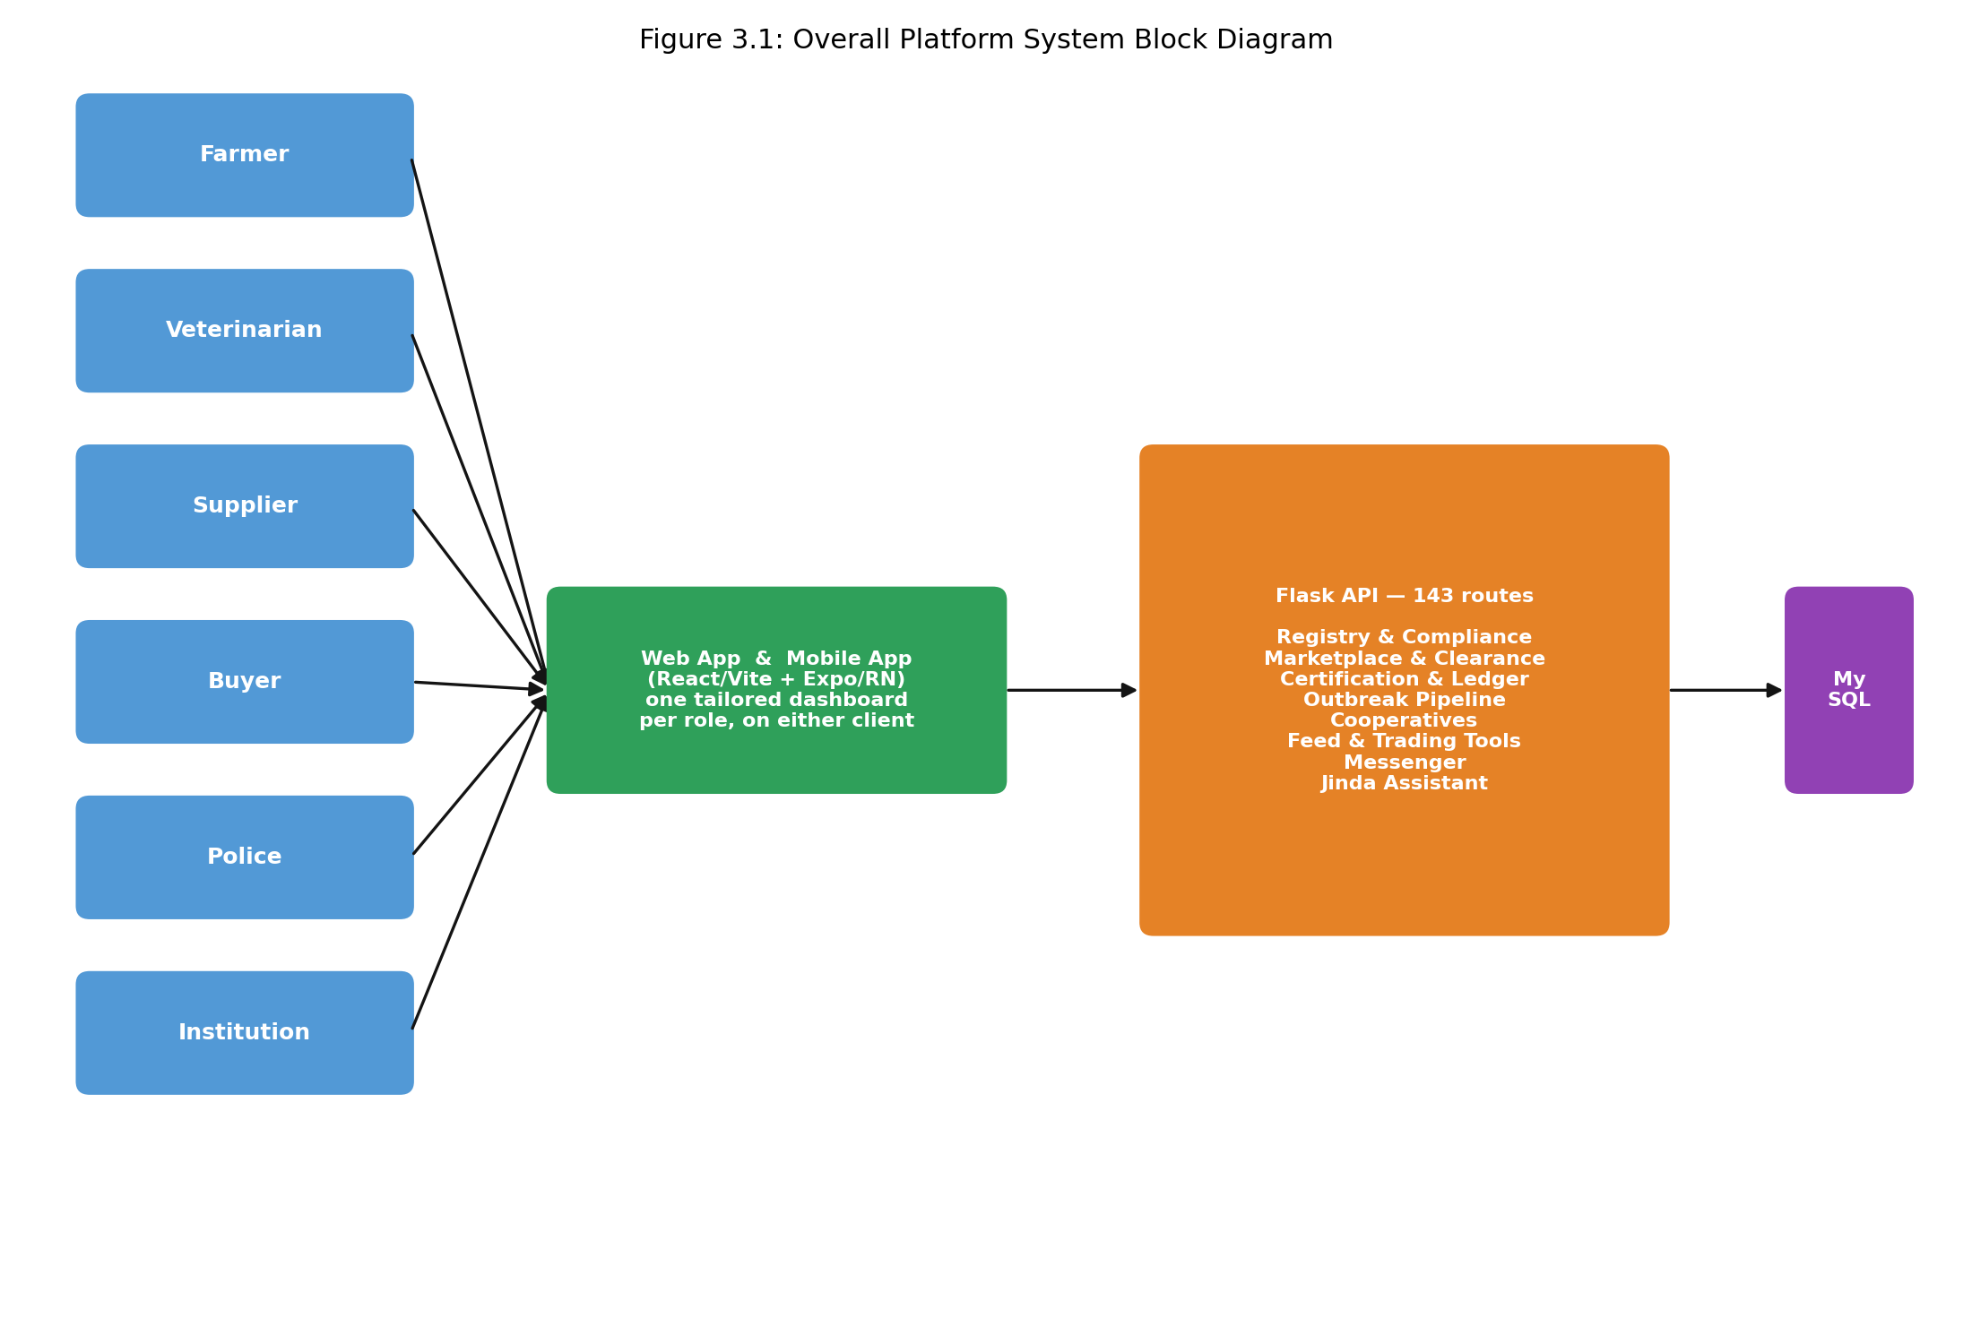
Figure 3.1: Overall platform system block diagram

A third client codebase, a WebView shell distributed as an installable mobile application, loads the web application's own interface rather than re-implementing it, and is therefore not a fourth architectural tier so much as an alternative packaging of the first.

3.3.2 Design Concept Selection
Each major technology choice was made against a named alternative, not by default.
Table 3.1: Technology choices and the alternative each was selected over
Layer | Chosen | Alternative considered | Reason
Backend framework | Flask | Django | A role-based application programming interface with no administrative site or templating need did not justify Django's larger, more opinionated footprint.
Database | MySQL | SQLite | Two concurrent client codebases writing to a shared database needed a real client-server engine with proper concurrent-write handling, not a single-file, single-writer database.
Authentication | JSON Web Token | Server-side session cookies | A mobile client with no shared browser cookie jar needed a bearer token it could store and attach itself, rather than a cookie tied to a browser session.
Web frontend | React with Vite | Next.js | The platform is a role-based dashboard behind authentication, not a public, search-indexed site, so server-side rendering and routing conventions aimed at public pages were not needed.
Mobile frontend | Expo and React Native | Flutter | Sharing one language, JavaScript, and a large share of business logic with the web codebase outweighed Flutter's rendering-performance advantage for a forms-and-lists application of this kind.
In-app assistant | Custom rule-based intent matching | A hosted third-party language model | A hosted model would have made every farmer query leave the platform to an external provider, cost money per call, and could answer a compliance question incorrectly with no way to audit why; a fixed, auditable rule set trades open-ended conversation for answers that are always traceable to a specific rule.

3.3.3 Database Schema Design
The schema is organised around a single users table carrying a role column, restricted to the values Farmer, Veterinarian, Supplier, Buyer, Police, Admin and Institution, with role-specific columns, such as a veterinary licence number or a police badge number, left null for every other role rather than split across seven separate tables. Every other table names the role it belongs to through a foreign key back to users, which is what makes a single access-control layer, rather than one per role, possible. The core entities and their relationships are summarised in Table 3.2.
Table 3.2: Core database entities and their relationships
Entity | Key relationships | Purpose
users | referenced by every other table below | One account per role per person; a farmer and a buyer sharing a phone number hold two separate rows.
animals | belongs to a users row (owner) | Identity, breed, tag and brand marks for one registered animal.
health_events / weight_history | belongs to animals | An animal's health and growth timeline.
compliance_cases / compliance_actions | belongs to animals; references users (vet, owner) | The vaccination-compliance escalation ladder (3.3.6).
marketplace_listings | belongs to users (seller); optionally links animals | A livestock, feed, produce, medicine or equipment listing.
sale_clearances / movement_permits | belongs to marketplace_listings and animals; references users (officer, vet) | Police and veterinary sign-off gating a livestock sale (3.3.5).
valuation_certificates / certificate_lookups | belongs to animals; references users (issuer, institution) | Vet-issued valuation and its institution-side ledger (3.3.7).
outbreaks | references users (reporter, verifier) | A disease report and its verify-then-broadcast state (3.3.8).
cooperatives / cooperative_members / cooperative_dip_schedule / cooperative_vet_requests | belongs to users (creator, members) | A shared farmer group and its dip-tank schedule (3.3.9).
feed_types / feeding_plans | belongs to animals, users | The feed-formulation ration builder (3.3.9).
conversations / conversation_messages | references users (both parties) | The cross-role messenger (3.3.10).

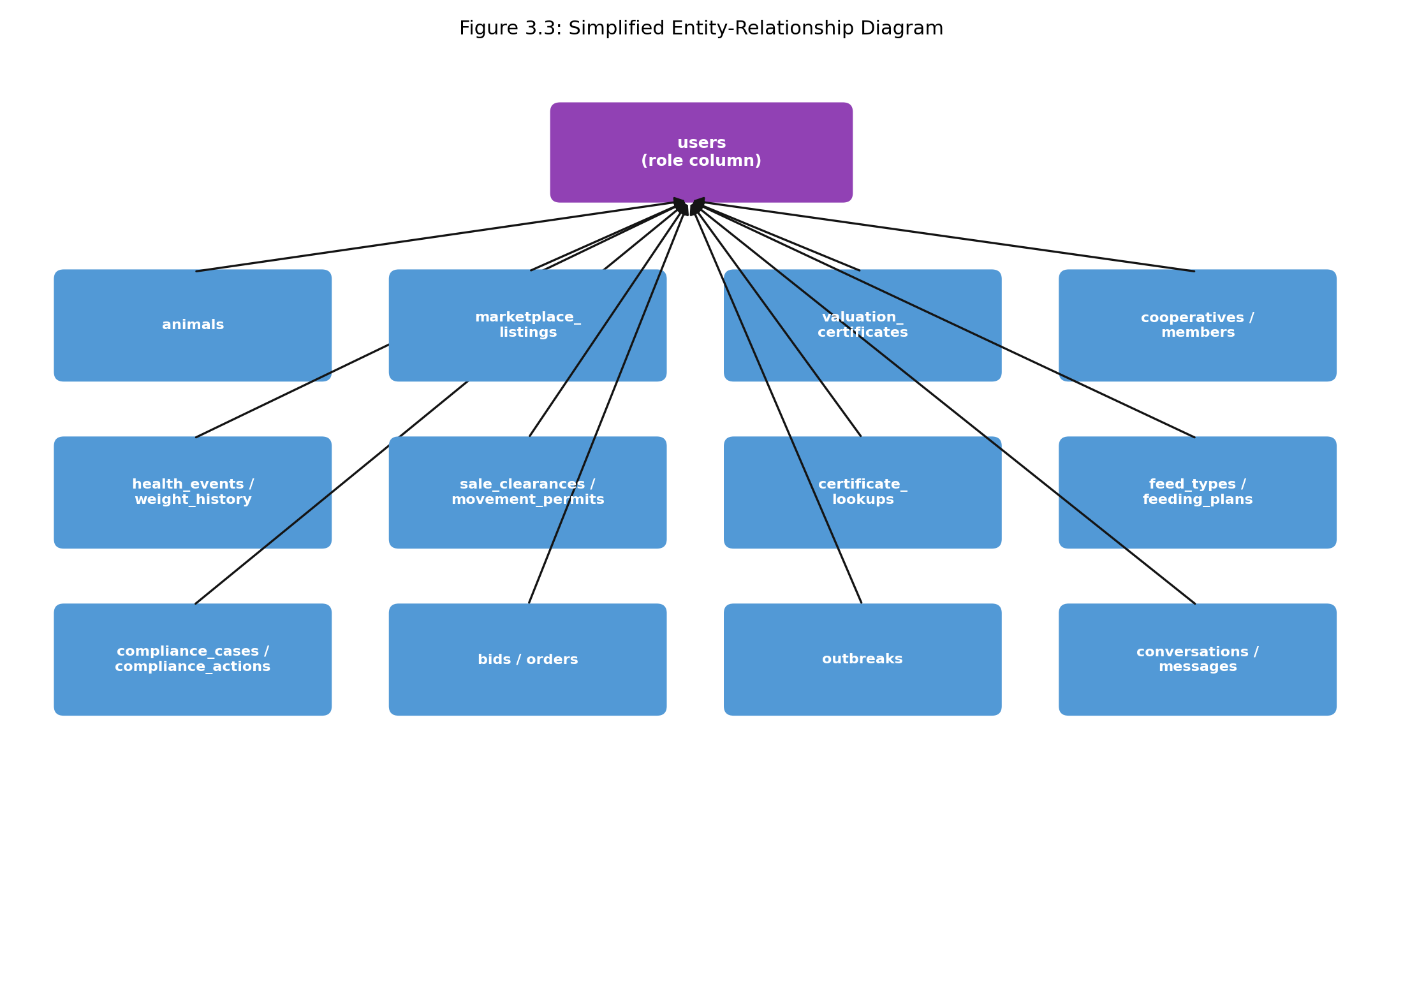
Figure 3.3: Simplified entity-relationship diagram

3.3.4 Role-Based Access-Control Design
Every authenticated request carries a JSON Web Token issued at login or registration, naming the requesting user's identifier and role; the server resolves the current user from that token on every request rather than trusting a role value the client might send. Data scoping follows from the same mechanism: a farmer's query for animals is always filtered to rows the farmer owns, and a police officer's or veterinary practitioner's oversight queries are scoped to their assigned province or district unless their officer_tier column is set to national, which is an administrator-assigned distinction a user cannot grant themself. The Admin role is deliberately undiscoverable: a protected route requested by a non-administrator returns the same not-found response a route that genuinely does not exist would return, rather than a forbidden response that would confirm the route exists. A newly registered account carries a verification_status of pending and is queued for a Police officer, or, for a Veterinarian applicant, an already-verified peer, to resolve to verified or rejected before the account is treated as fully trusted elsewhere in the platform — the same pending-to-resolved pattern described fully in 3.3.5 and shown in Figure 3.2.

3.3.5 Marketplace and Sale-Clearance Workflow Design
A marketplace listing carries a status of pending_clearance, available, sold or withdrawn. A listing created against a registered animal starts as pending_clearance and is excluded from the public listings query, which filters strictly on status equals available, until a police officer resolves a linked sale_clearances row to cleared. That row digitises the Zimbabwe Republic Police's own paper Form 392 Livestock Clearance Certificate field for field, including an optional traditional-authority attestation by a village head or chief for communal-area sales, and a separate movement_permits table digitising the Department of Veterinary Services' Form V27 for a cross-district move. Unlike a sale clearance, a movement permit is issued by a veterinary practitioner rather than a police officer, requiring the vet's professional rank, VEA, AHI or GVO, and an uploaded signature before the permit number is generated, matching the paper form's own requirement that nothing is authorised until that line is signed. A sale arranged off the platform, for example between neighbours, is additionally supported through a short transfer code a seller generates and a buyer redeems, which moves ownership and the animal's full history the same way an ordinary marketplace sale does.
The clearance itself follows a single pattern reused four times across the platform, shown in Figure 3.2: an action is created and immediately held pending, an authority reviews it, and it is then either released, becoming visible or effective, or rejected and kept hidden. The same shape governs a new account's signup verification (3.3.4), a movement permit (above), and an outbreak report before it broadcasts (3.3.8) — it is one mechanism applied four times, not four separate ones.
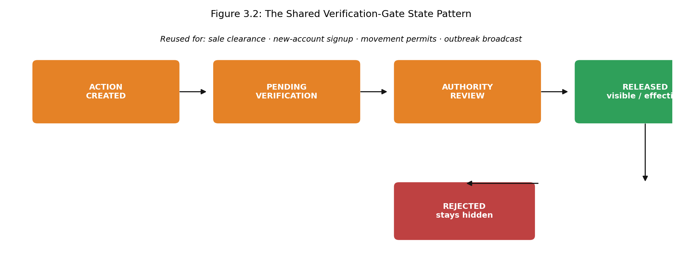
Figure 3.2: The shared verification-gate state pattern

3.3.6 Health-and-Compliance Lifecycle Design
A server-side protocol table, independent of anything the client sends, names every mandatory vaccination per species together with the animal age it first falls due and, where applicable, its recurrence interval. A missed mandatory vaccination does not merely mark a dashboard red; it opens a compliance_cases row that escalates through a fixed stage ladder, reminder, then vet follow-up, then a formal notice, then a penalty. The penalty is a trade lock confined to that one animal, not a monetary fine the platform has no lawful way to collect and no right to impose on a subsistence farmer. A farmer may instead declare a blocker, such as the vaccine being out of stock or no veterinary officer having visited the ward, which pauses the ladder without penalty and routes the case to whichever party, a supplier, a dispatched vet, or the farmer's cooperative, can actually resolve it. Every stage transition is written to a separate compliance_actions row, so a lockout can always be explained, and disputed, after the fact.

3.3.7 Certification and Institution-Ledger Design
An animal's owner, or an administrator, may issue a valuation_certificates row for that animal, carrying a unique verification code; the certificate's value is not client-supplied but computed server-side from the animal's current weight, a per-species market rate, and a bonus derived from the count of health_events logged against that animal, so a veterinary practitioner's role is indirect, through the health events a certificate's value is partly built from, rather than through issuing the certificate itself. That code can be resolved through a public endpoint requiring no PFUMA/INGCEBO account, so a bank or insurer's loan officer can check it directly. A financial institution that looks a certificate up may additionally flag it in a certificate_lookups row as held collateral, which lets a second lender see that a certificate is already pledged without either institution learning who the other is.

3.3.8 Outbreak-Reporting Pipeline Design
A disease outbreak reported by a veterinary practitioner or police officer is written with a verified_status of pending and is not visible to farmers in that province. It becomes visible, functioning as a broadcast alert, only once an officer whose own officer_tier is national resolves it to verified, which is the same pending-to-verified-to-released pattern used for sale clearance in 3.3.5, applied here to prevent a single unreviewed field report from triggering a province-wide panic notification.

3.3.9 Cooperative, Feed and Trading-Journal Design
A cooperative row groups farmer members who share a physical dip tank; any member may propose a dip_schedule entry or raise a cooperative_vet_requests row on the group's behalf, so a veterinary practitioner sees one consolidated request rather than each member messaging individually. Independently, a feeding_plans row is generated by computing a specific animal's daily protein and energy requirement from its species, weight and life stage, then pricing candidate feed_types items against live marketplace listings where a price exists, and recording whether the resulting ration is deficient, balanced or in excess against that requirement. The trading journal is a separate, read-only summary restricted to the Supplier and Buyer roles: a supplier's view totals their own fulfilled orders, and a buyer's view totals their own accepted bids, each against the same orders and bids rows the marketplace already writes, so no farmer-facing sale/purchase history is kept under this name.

3.3.10 Messenger and Jinda Assistant Design
The cross-role messenger is deliberately general-purpose: a conversation is a thread between any two verified users, not a mechanism restricted to a fixed pair of roles, so a farmer, a veterinary practitioner, a supplier, a buyer, a police officer and an institution can each reach any other directly. The in-app assistant, named Jinda, is implemented as deterministic rule-based intent matching rather than a hosted language model: an incoming message is scanned with whole-word regular expressions against alias dictionaries for species and role, checked against a fixed, priority-ordered list of intents, for example a police-only clearance query is only ever matched for a police account, and, where no specific intent matches, against a navigation keyword table that switches the requesting client to the relevant screen. The assistant also recognises marker words for Shona and Ndebele, Zimbabwe's two most widely spoken indigenous languages alongside English, so a query typed in either is still routed correctly. Because every answer traces back to a named rule rather than a statistical model's output, an incorrect answer can be located and fixed at its source, which a hosted model's output cannot.

3.4 CONCLUSION
This chapter has presented the platform's three-tier architecture, the alternative rejected for each major technology choice, the shared database schema underlying every role, and the design of each of the ten cross-cutting workflows in turn. Chapter 4 reports the results of exercising this design against the running platform.

CHAPTER 4 RESULTS ANALYSIS

4.1 INTRODUCTION
This chapter reports the results of exercising the implemented platform's workflows against its own application programming interface and database, running locally, and interprets those results against the fifteen objectives stated in Chapter 1. Every result reported as observed in Section 4.3 was produced by an actual request against the running system on 19 September 2026; nothing is inferred from source code alone.

4.2 [SECTION TO BE CONFIRMED WITH SUPERVISOR]
[ Pending: mirrors the open question in Chapter 3 — the guidelines template names this "Hardware Test Results", which does not apply to a pure software submission. ]

4.3 SOFTWARE TEST RESULTS
Table 4.1 summarises the outcome of exercising each workflow. Full detail follows the table for results that need it.
Table 4.1: Workflow test summary
Workflow | Test performed | Result observed
Authentication | Register a new Farmer account; log in with correct and incorrect passwords | 201 on registration, 200 with a token on correct password, 401 on incorrect password
Registry | Read an existing animal's identity, weight history and health events | Returned Bessie's full record correctly
Marketplace and sale clearance | Query the public listings feed while a linked listing's clearance was pending | Listing withheld until status changed to available; confirmed in an earlier session against the live SQL query and the API response together
Valuation certificate and institution ledger | Issue a valuation certificate; verify it with no authentication; look it up and flag it as an Institution; verify again | Certificate issued at the correct computed value; public verification succeeded; institution flag recorded; second verification correctly reported already_pledged
Movement permit | Request a permit as a Farmer; issue it as a Veterinarian with a rank and an uploaded signature | Requested successfully, appeared in the Veterinarian's pending list, and issued with a generated permit number
Outbreak reporting and verification | Report an outbreak as a Veterinarian; confirm it is hidden from a Farmer; promote a Police officer to national tier and verify it; confirm it becomes visible | Hidden before verification (empty result), 5 farmers notified on verification, visible afterward
Farmer cooperatives | Create a cooperative; raise a dip-tank schedule entry; raise a group veterinary request; confirm a Veterinarian sees it in their own province-scoped queue | All four steps succeeded; the request appeared in the Veterinarian's queue with the cooperative's name attached
Health-and-compliance lifecycle | Read the compliance case queue for an owner with animals carrying overdue vaccinations | 25 cases returned, auto-opened and already escalated from reminder to vet_followup by elapsed time alone, with no case yet trade-locked
Feed formulation | Read the computed feed requirement for a specific animal; read the dry-season feed budget for the owner's whole herd | Correct per-animal energy/protein target returned; herd-wide budget returned a real total costed against a live marketplace listing
Trading journal | Read the trading journal as a Buyer | Returned real totals computed from that Buyer's own accepted bids
Messenger | Start a conversation from a Farmer to a Veterinarian; send a message; read it back as the Veterinarian | Conversation created, message stored and delivered both ways
Signup verification | Register a new Farmer account; confirm it appears in the Police pending queue; verify it | Appeared correctly in the queue; verification changed its status and the account could then log in fully verified
Marketplace bidding | Place a bid as a Buyer on a feed listing; accept it as the seller | Bid recorded and visible to the seller; accepting it marked the listing sold
Supplier order fulfilment | List a medicine item as a Supplier; order it as a Farmer; dispatch and deliver it as the Supplier | Full lifecycle completed; both dispatch and delivery are confirmed by the Supplier, not the ordering Farmer, which the endpoint enforces by role rather than by who placed the order
Off-platform animal transfer | Generate a transfer code for an animal as its owner; redeem the code as a different Farmer account | Code generated, redeemed successfully, and ownership together with the animal's full history moved to the new owner
Market-rate scan | Read the current market rates | Returned real, sourced per-species rates from a prior scan; a fresh scan attempted during this test session did not complete within the time allowed and is not reported as re-verified
Web application (browser) | Load the web application in a real browser session, log in, and navigate its pages | Logged in correctly; the dashboard, vaccination follow-up and marketplace pages all rendered live data matching the API results above, including a “Police cleared” badge on a genuinely cleared listing
Jinda assistant (browser) | Open Jinda in the logged-in web application; ask a Shona-language navigation request; ask an open-ended reasoning question | The Shona request (“ndoda kuenda ku marketplace”) was correctly recognised and the application actually navigated to the Marketplace section. The open-ended question (why a specific vaccine was overdue and what ignoring it would do) was not answered on its merits; the assistant matched a generic health-related keyword and navigated to the Health section instead, without answering the why/what-happens part of the question

Two results corrected an assumption carried over, unverified, from the platform's own descriptive documentation. First, issuing a valuation certificate was assumed to be a veterinary action; testing showed the endpoint instead requires the animal's owner, or an administrator, and computes the certificate's value itself from the animal's weight, a per-species market rate, and a bonus derived from the count of logged health events, so a veterinary practitioner's involvement is indirect, through the health events a farmer's certificate value is partly built from, rather than direct. This does not extend to every certifying action in the platform: the movement permit, tested separately above, is issued directly by a veterinary practitioner, who must supply a professional rank and an uploaded signature before a permit number is generated, so a veterinary practitioner's certifying role is real, just attached to the movement permit rather than the valuation certificate. Second, the trading journal was assumed to record a farmer's own sale and purchase history; testing showed it is restricted to the Supplier and Buyer roles and summarises a supplier's fulfilled orders or a buyer's accepted bids, not a farmer's. Both corrections are reflected in Chapter 1 and Chapter 3 as written; the discrepancy is recorded here because it was testing, not code reading alone, that surfaced it.
The health-and-compliance result is worth stating precisely. The 25 returned cases were not seeded as cases; they were computed at request time from each animal's species-specific vaccination protocol and birth date, compared against the system's current date, and the two already escalated from reminder to vet_followup were escalated because the reminder stage's own grace period had genuinely elapsed by that date, not because a stage value was inserted directly. This is the one result in this chapter that demonstrates a computation over time, rather than a single request-response exchange.
The Jinda result is reported honestly rather than favourably. The assistant's rule-based design (Chapter 3, 3.3.10) succeeds exactly where it was designed to: a request that matches a known intent, including one typed in Shona, is recognised and acted on, not merely translated. It does not succeed at open-ended reasoning, because it was never designed to: asked why a specific vaccine was overdue and what ignoring it would do, it matched the nearest keyword category and navigated there instead of answering, since no fixed rule exists for that specific compound question. This is the direct, honest consequence of the design choice recorded in Table 3.1, trading open-ended conversation for answers that are always traceable to a specific rule, and it is reported here rather than smoothed over.

4.4 INTERPRETATION OF RESULTS
Every workflow objective stated in Chapter 1, objectives two through nine and eleven through fourteen, was exercised successfully against the running platform, with the two corrections noted above now folded back into the earlier chapters rather than left as a discrepancy between documentation and behaviour. Objective twelve, the native mobile application, was confirmed to build and to reach the same backend correctly, but was not physically exercised on a device or emulator within this study, since none was available in the environment this testing was carried out in; this is recorded as a genuine limitation rather than claimed as tested. Objective fourteen's assistant was exercised honestly rather than favourably, as described above: it succeeds at its designed task and does not overreach into a task it was never designed for. Objective fifteen, determining whether the platform's workflows operate correctly end to end, is itself answered by this chapter: with the one noted exception of the mobile client's physical exercise, they do, on the evidence gathered here. The one incomplete result, the market-rate scan re-trigger, reflects a session-specific network condition during testing rather than a defect in the scan itself, since the rates endpoint already held a genuine successful scan from an earlier date and returned it correctly when read.

4.5 CONCLUSION
This chapter has reported that every implemented workflow operates correctly against the running platform, evidenced by actual requests and their actual responses rather than by reading the source code alone, and that doing so surfaced two genuine inaccuracies in the platform's own prior documentation that code reading alone had not caught. Chapter 5 concludes the study.

CHAPTER 5 RECOMMENDATION AND CONCLUSION

5.1 INTRODUCTION
This chapter presents recommendations arising from the study, identifies future work delimited out of the current submission, and concludes the dissertation.

5.2 RECOMMENDATIONS
Three recommendations follow directly from the limitations recorded in Chapter 1. First, before any real deployment beyond a controlled demonstration, the Zimbabwe Republic Police and the Department of Veterinary Services should be approached formally about a data-sharing arrangement, so that the Police and outbreak-verification roles can eventually check against those organisations' own records rather than a self-contained copy held inside the platform's own database. Second, the legal and regulatory content the platform surfaces to users, currently researched from public statutes and secondary sources, should be reviewed by a qualified Zimbabwean lawyer before being relied upon in a real transaction or dispute. Third, a small field trial with a single farmer cooperative is recommended as the next step before any wider rollout, so that the usability judgements made in this study by the researcher and informal reviewers can be checked against the platform's actual intended users.

5.3 FUTURE WORK
The physical livestock-tracking hardware explored earlier in the platform's design, and deliberately delimited out of this software-only submission, remains a plausible future extension and should be evaluated as its own project rather than folded back into this one. Integration with the national electronic ear-tag identification programme, where the platform's brand and tag fields could eventually be reconciled against a government-run identity source rather than a self-reported one, is a second candidate. A third is broadening species coverage beyond the four covered here, cattle, goats, sheep and pigs, to poultry, which the study's delimitations excluded but which the existing schema and role structure would not need to be redesigned to accommodate. A fourth, smaller extension follows directly from the Jinda assistant's existing Shona and Ndebele marker-word detection: a fuller local-language interface, beyond query recognition, for a user who is more comfortable reading and writing in one of those languages than in English.

5.4 CONCLUSION
This study set out to develop a role-based digital platform connecting the farmer, the veterinary practitioner, the supplier, the buyer, the police officer and a financial institution around a single verified livestock record, in place of the paper-based, unshared records each of them keeps today. Chapter 1 established that gap and stated fifteen objectives against it; Chapter 3 presented a design meeting each of them, spanning the herd registry, the health-and-compliance lifecycle, the marketplace and its police-gated sale clearance, the valuation certificate and the institution ledger, outbreak reporting, farmer cooperatives, feed formulation and the trading journal, an estimated-value calculation, a web application and a native mobile application, a cross-role messenger, and the Jinda assistant; Chapter 4 reported the results of exercising that design against the running platform. The recommendations and future work above mark what a real deployment would still need, but they concern extending and validating the platform in the field, not completing work the study left undone. The aim stated in Chapter 1 was met.

REFERENCES
[1] Zimbabwe (1959, as amended 2001). Stock Theft Prevention Act [Chapter 9:18]. Harare: Government of Zimbabwe.
[2] Zimbabwe (1900, as amended). Brands Act. Harare: Government of Zimbabwe.
[3] Zimbabwe. Animal Health Act [Chapter 19:01]. Harare: Government of Zimbabwe.
[4] Zimbabwe. Veterinary Surgeons Act [Chapter 27:15]. Harare: Government of Zimbabwe.

